MySQL Assignment 1 - DDL Commands, Constraints

- Tasks:
- DDL Commands
1.Database and Table Creation (CREATE):
- Create a Database for this project
- Create all three tables in MySQL with appropriate data types and relationships.
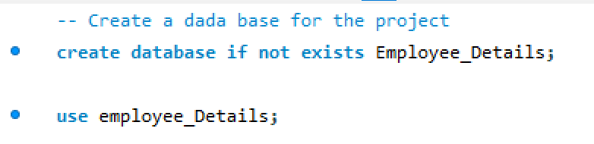
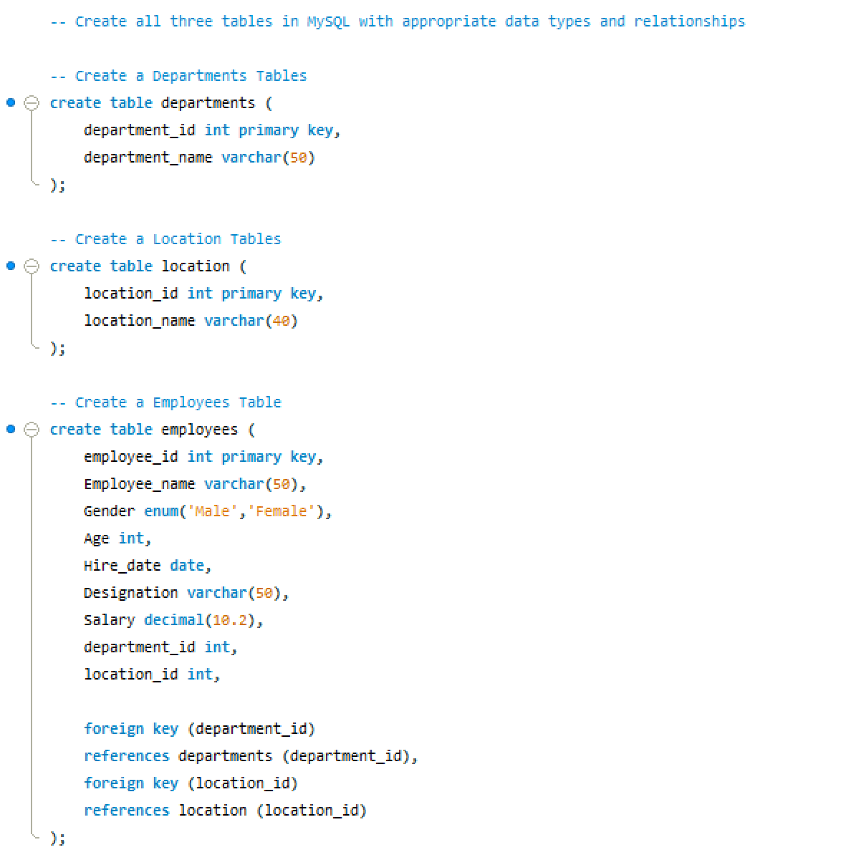

2. Table Alteration (ALTER)
- Add a new column named "email" to the Employees table to store employee email addresses.
- Modify the data type of the "designation" column in the Employees table to support a wider range of values.
- Drop the “age” column from the Employees table.
- Rename the “hire_date” column to “date_of_joining”.
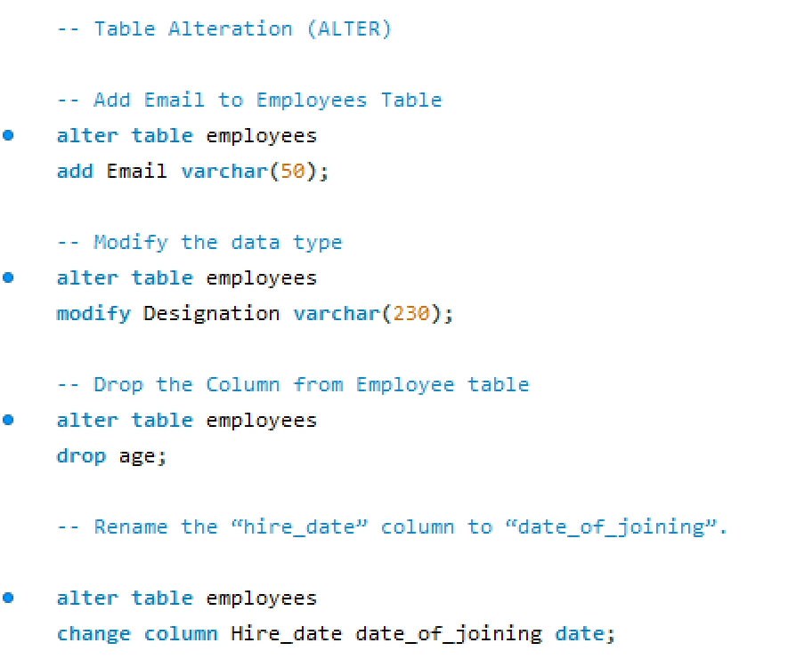
3. Table Renaming (RENAME):
- Rename the "Departments" table to "Departments_Info".
- Rename the "Location" table to "Locations".
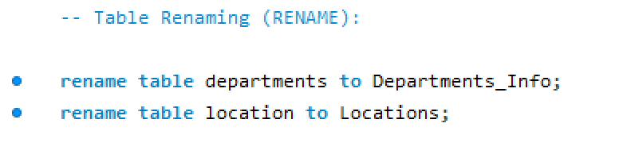
4. Table Truncation (TRUNCATE):
- Truncate the Employees table.
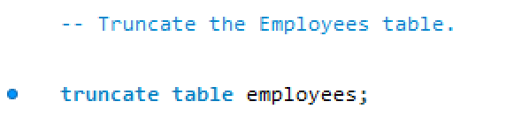

5. Database & Table Dropping (DROP):
- Drop the Employees table and then the “employee” database.
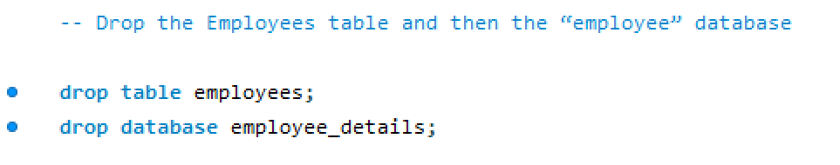

- Tasks: Constraints :
1.Database Recreation:
- Drop the 'employee' database if it exists
- Recreate it using the provided schema, ensuring that all tables are created with the appropriate constraints as instructed.
- Establish links between the "department_id" and "location_id" fields in the "employees" table and their respective tables.
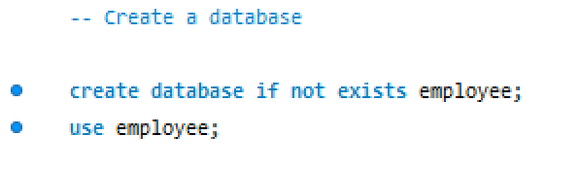
2. Departments Table:
- Ensure that the "department_id" uniquely identifies each department.
- Set up constraints on the "department_name" to avoid duplicate and null entries.
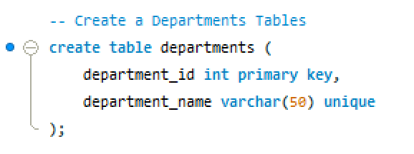
3. Locations Table:
- Establish a mechanism to automatically generate unique identifiers for each location, ensuring that they are incremented sequentially.
- Implement constraints to prevent the insertion of null and duplicate locations.
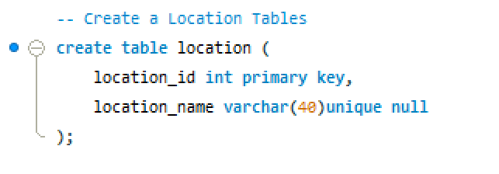
4. Employees Table:
- Guarantee that each employee has a distinct identifier.
- Create a restriction to ensure that the employee's name is always provided.
- Limit the acceptable values for the "gender" field to only 'M' or 'F'.
- Enforce a condition to ensure that the employee's age is 18 or above.
- Automatically assign the current date to the "hire_date" field if not specified.
